**DEVADHARSHINI .M**

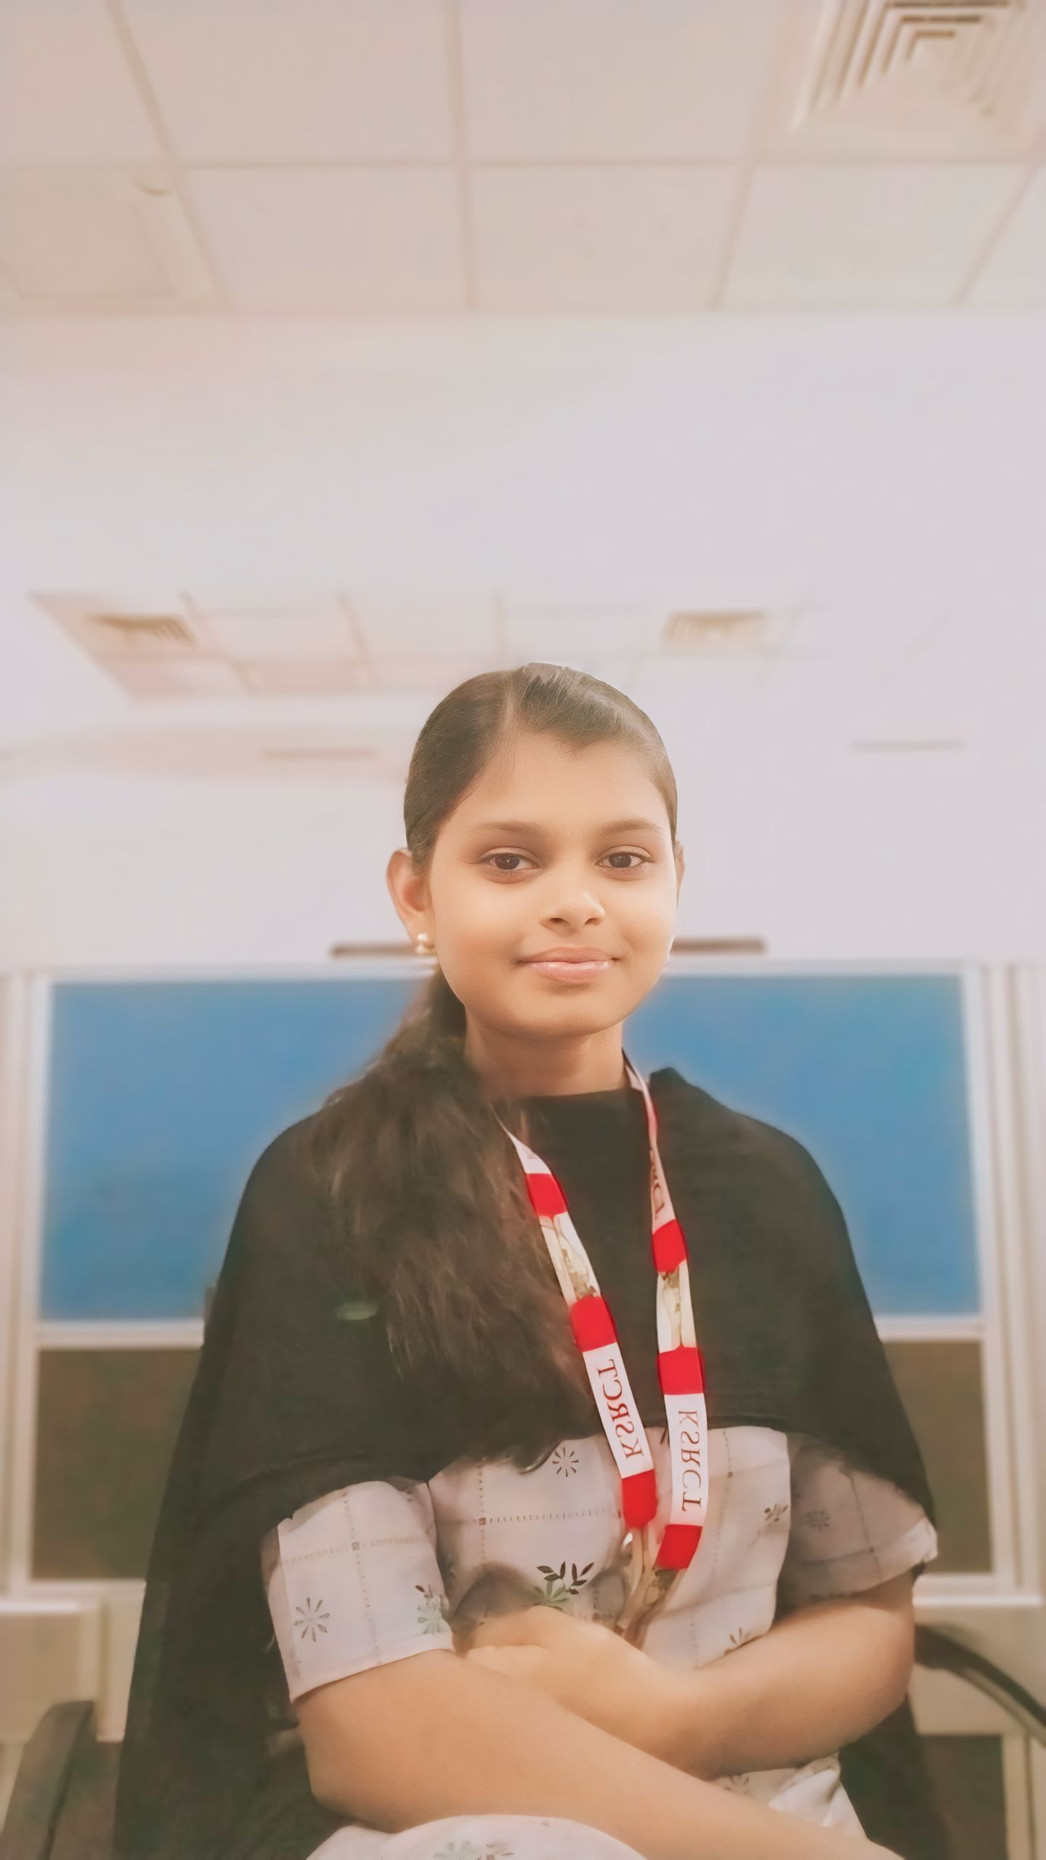

Email :dd1472945@gmail.com

Mobile No :9043368998

LinkedIn : www.linkedin.com/in/devadharshini998

GitHub : https://github.com/Devadharshinimahendran

HackerRank : https://www.hackerrank.com/profile/dd1472945

**Career Objective:**

To secure a placement position at a leading technology organization where I can utilize my academic background in software development, engage in impactful projects, and gain valuable industry experience. I aim to contribute effectively to the team while developing my technical and professional skills.

**EDUCATIONAL QUALIFICATION**

|  |  |  |  |  |
| --- | --- | --- | --- | --- |
| **Course** | **Name of the Institution** | **University/Board** | **Month & Year of passing** | **CGPA/Percentage** |
| B.Tech Computer science and Business Systems | K. S. Rangasamy college of  Technology  (*Autonomous*),  Tiruchengode | Anna University,  Chennai | May,2027 | 8.90(At 1st sem) |
| HSC | Vishwesvaraiyah.matric.hr.sec.school  thoppur | State Board  (Tamil Nadu) | March,2023 | 91%  138.5(cut off) |
| SSLC | Vishwesvaraiyah.matric.hr.sec.school  thoppur | State Board  (Tamil Nadu) | March,2021 | All Pass |

**TECHNICAL SKILLS**

Known coding languages

|  |  |
| --- | --- |
| * Java | * HTML |
| * C | * CSS |
| * Python | * MERN Stack |

**MINI PROJECTS**

* **A Project for Bank Management System**

We successfully developed a comprehensive Bank Management System using Java, incorporating features like account creation, transaction processing, and customer management. Leveraging Java's robustness and scalability, our system ensures secure and efficient banking operations. With a user-friendly interface and robust backend, our project streamlines banking processes, enhancing customer experience and operational productivity

**CO -CURRICULAR ACTIVITIES**

Workshop:

Participated in the workshop on **Cyber Security tools** at **Vinayaka Mission’s Kirupananda Engineering College**, Salem during 03 Apl 2024 and grain the interest in the field of security side in the technological world.

Online Course:

Here are the course completions you mentioned in a point format:

1. **Introduction to Cybersecurity** on Great Learning

2. **Collections in Java** on Great Learning

3. **Introduction to R** on Great Learning

4. **Core Java Specification** on Coursera

5. **UiPath Automation Explorer for Students** through the UiPath Academic Alliance

**PERSONAL PROFILE**

Father’s name :Mr. V.Mahendran

Mother’s name :Mrs.B. Rathi

DOB & Age :10.12.2005 & 18 years.

Personal Traits :Discipline,Problem solving skill, Self-Motivation,Leadership,Adaptability.

Hobbies :Playing football,listening music.